A small guide to set up and create a project within PHPStorm
Some preconditions:
- You have installed the PHPStorm (follow: Download + Instal PhpStorm)
- You have installed XAMPP (follow: Installing and Configuring XAMPP with PhpStorm IDE)
- You have stated the Apache server.

Step 1: Start the Apache server
Start Xampp, and start the Apache server. You will then see which port it is started on:
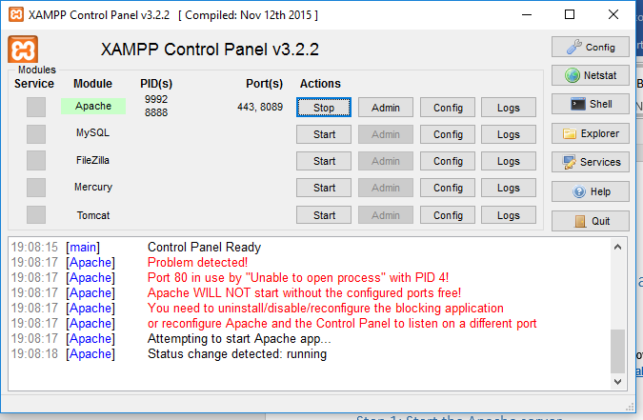
In this case port 8089.

Step 2: Start PHPStorm

Step 3: Create a new project
You will see:
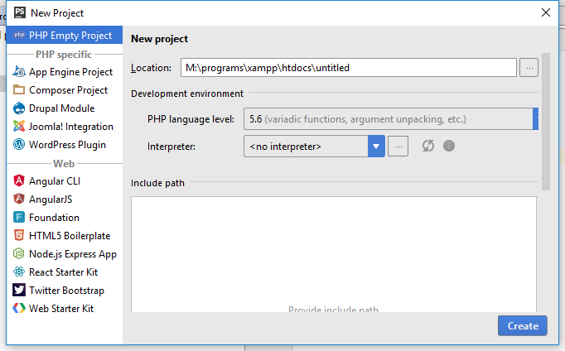
PHP interpreter dropdown
For the location use “<<XAMPP-Root>>\htdocs\<<your project name>>” Here the xampp is installed in the folder named “M:\programs\xampp” and here the project name is “untitled”, change this to some good project name e.g. MyFirstPHP: The full path should then be “M:\programs\xampp\htdocs\MyFirstPHP”.
For the PHP interpreter choose the php coming with xampp i.e. click on the … - button and you will see: click on the + -button and give a name
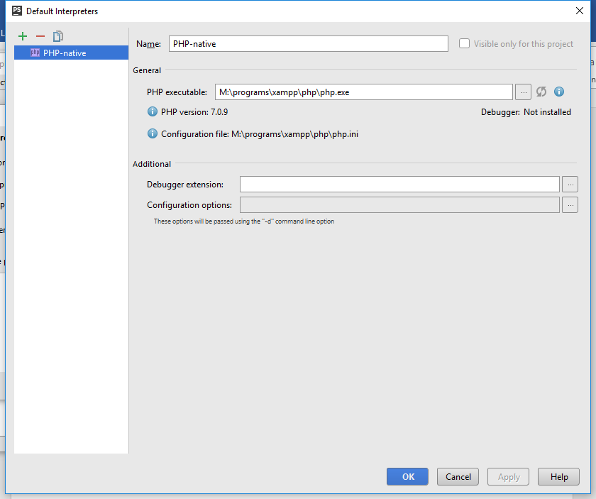
Chose a PHP interpreter “<<XAMPP-root>>\PHP\php.exe”.
After this first time you can use the drop down menu to pick the PHP interpreter by the name you have given.

Step 4: Create files for your project
You will have a picture like:
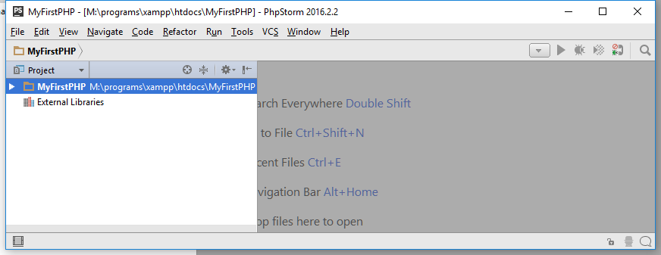
Right click on the project and choose new (html, php, stylesheet … ) to make new files.
e.g. Create an index.html file and a PostPage.php file and it looks like this:
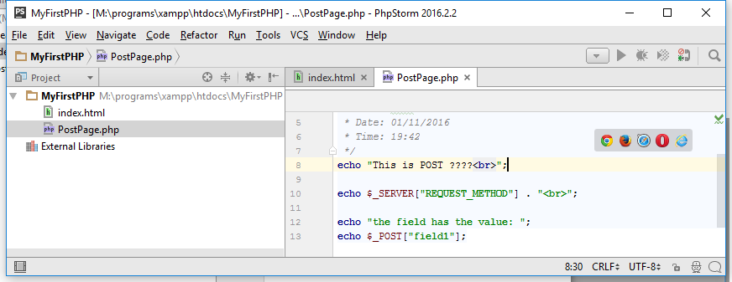

Step 5: Run the PHP application
Right click on the file you will run e.g. “index.html”.
Then go back and configure the running of this application, edit the run configuration file:
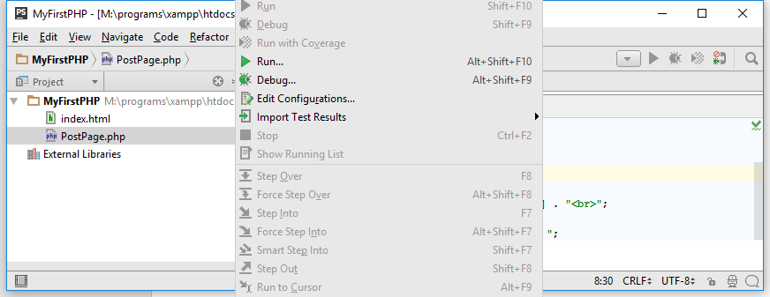
Then comes:
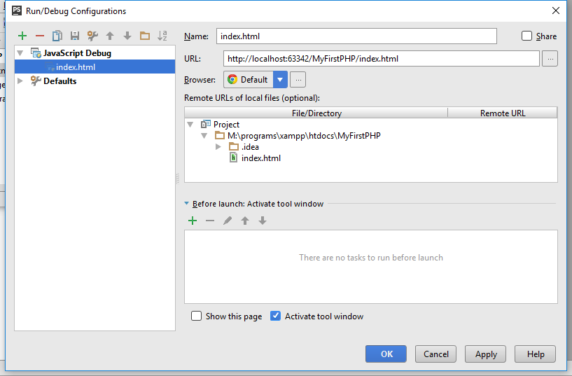
Now change the URL to use the port number of Apache: In this case “8089” and ‘OK’.
When you now have :
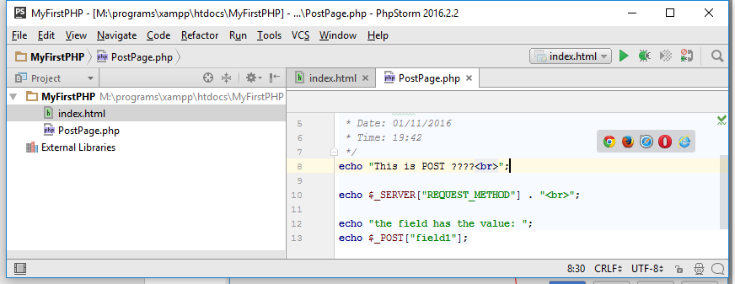
AND YOU CAN NOW RUN YOU APPLICATION BY THE GREEN ARROW – Congratulations

