Dear Students
Zealand Institute of business and Technology has decided that all the exams from this summer should be in Wiseflow – a digital exams system.
You have to log on to your school mail – see the instructions on the next page.
You will receive an email from Wiseflow with your username and password. At the exam you have to log in to Wiseflow: easj.wiseflow.dk (use Firefox or chrome) then you choose Unilogin and login with your username and password.
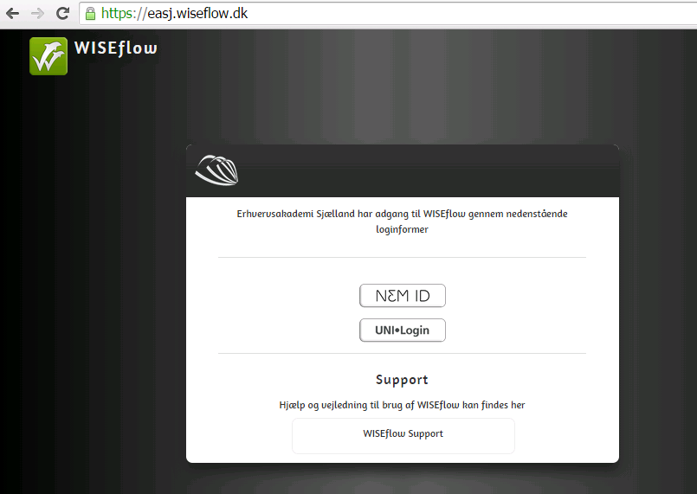

When you are logged in you can see your exam. You have to submit your written project and appendix as a PDF file. It is very important that you have uploaded/ submitted your project before the deadline, otherwise you can’t submit your project.

Please don’t hesitate to come to the administration or contact us via phone: 5076 2659, if you have any questions
Office 365 contains access to e-mail via Outlook Web App and storage via OneDrive
Your e-mail address is: username@edu.easj.dk. Your username is the same as your username to UNI-login, so if your username is Lara123x, then your e-mail will be: lara123x@edu.easj.dk.
Your password is the word Password, with capital P, with the last four digits of your CPR number. So if your last four digits are 1820, then your Password will be: Password1820.
To get to the website use this web address: https://portal.microsoftonline.com
